Project 5 Report
For: Garrison Diversion Project & Red River Valley Water Supply Project (RRVWSP)
Author: Blake Green

Table of Contents

Table of Contents 2
Table of Figures 2
Table of Tables 2
Introduction 3
Methods 4
Results and Discussion 6
References 11

Table of Figures
Figure 1 - Flow Chart of Methods 5
Figure 2 - Bar Chart of TDS Concentrations 8
Figure 3 - Boxplots of 6 Parameters Along the Canal 9
Figure 4 - Mass Balance Equation 9
Figure 5 - Temporal Trend Analysis 10

Table of Tables
Table 1 - Summary Statistics of Major Parameters 6
Table 2 - Mass Balance Python Output Table 9

Introduction
The project was developed for the Garrison Diversion Project and the Red River Valley Water Supply Project (RRVWSP), which are working to address water supply issues in eastern North Dakota. Due to droughts and increasing demand the current water sources have not been as reliable or stable as previously thought. A pipeline has been proposed to transport water from Lake Sakakawea to the Sheyenne River. This ends up feeding to Lake Ashtabula. Our job is to evaluate the water quality as it moves through the McClusky Canal system to make sure that all parameters meet standards.
The water quality data was obtained from the United States Geological Survey National Water Information System and was provided by the client for analysis. These datasets provide measurements of chemical parameters such as Total Dissolved Solids (TDS), sulfate, major cations, and other indicators that would affect water quality for drinking, agriculture, and other uses.
An analysis of this data was conducted using Python to organize and find summary statistics for the raw USGS dataset. The boxplots were generated using Python as well and were used to display the data for the client. Temporal trend analysis was also done using regression lines to determine whether water quality conditions improved or deteriorated over time.
Overall, this report will provide an assessment of water quality conditions within the McClusky Canal system and will evaluate the potential impacts of the proposed pipeline.

Methods
This project evaluates the water quality changes from Lake Sakakawea through the McClusky Canal and assesses impacts downstream on the Sheyenne River and Lake Ashtabula. All analyses were made using the client provided USGS dataset. The following provides detailed information on the methods performed.
The first step in the analysis was to organize the water quality data set by location. The data was sorted by the site identification. Once the data is grouped, the data set for each parameter (cations/anions, TDS, Temperature, pH, and Total Hardness) was checked for irregularities or missing entries. These were then removed so that they did not impact the statistical calculations in the future.
To compare the water quality along the canal, statistics were calculated for each location using Python. For each parameter that we are interested in we calculate the mean, median, max, and min using standard functions. These values are then put into a table for easy comparison to other locations between Lake Sakakawea and downstream points. This step helps to find trends and indicators to determine if water quality degradation truly does occur along the canal.
The next step is to visually compare the water quality data by creating box plots for at least four key parameters. The boxplots were generated using cleaned and grouped datasets with sampling location on the x-axis and the parameter concentration on the y-axis. The boxplots show the median, interquartile range, spread, and presence of outliers for each location. The visualizations were made with functions from matplotlib and seaborn to create the plots. This step helps identify if a parameter shows increasing concentration as water moves through the canal.
Finally, a mass balance equation needs to be applied to calculate the final concentration of TDS in Lake Ashtabula after mixing water from the pipeline and Sheyenne River. The pipeline flow rate is set to 6 cfs, and the Sheyenne River Flow Rate is obtained from the data set. The concentration for the pipeline input was assumed to match the concentration measured at the McClusky Canal inlet. Then inputting the equation Q_{P}C_{P} + Q_{S}C_{S} = Q_{a}C_{a} into Python as a function the flow rates and concentrations were input by the user to solve for the final mixed concentration and total flow. This was set up as a function with inputs so that flow rates and concentrations could easily be changed and manipulated to allow for different scenarios to be analyzed.
After all these steps have been complete, the parameters showing the largest increases, highest values, or other potential water quality risks were identified. These parameters were then evaluated based on the relevance to the Sheyenne River and Lake Ashtabula.
A flow chart was created to help visualize the analysis process and is shown in Figure 1. This is consistent with the methods followed throughout the project and was referenced to ensure transparency of results to make sure they matched the methods.
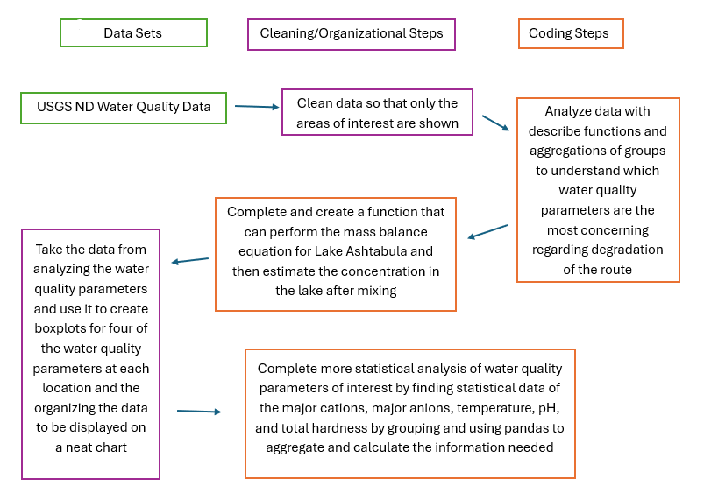
Figure 1 - Flow Chart of Methods

Results and Discussion
The first data that was gained was the summary statistics for major water quality parameters for each canal reservoir from Lake Sakakawea to Lake Ashtabula. These values shown in Table 1 include the mean, median, minimum, maximum, and sample size of all the major parameters.
Table 1 - Summary Statistics of Major Parameters
Parameter | Location | Mean (mg/L) | Median (mg/L) | Max (mg/L) | Min  (mg/L) | N (# of samples)
 | Lake Sakakawea | 49.5 | 49.5 | 56.1 | 41.0 | 78
 | Lake Audubon | 42.0 | 42.1 | 43.7 | 40.0 | 4
 | New Johns Lake | 82.7 | 81.2 | 93.3 | 73.4 | 7
Calcium | West Park Lake | 49.0 | 48.9 | 55.1 | 44.9 | 7
 | East Park Lake | 57.8 | 56.6 | 67.4 | 49.1 | 7
 | Heckers Lake | 70.6 | 70.1 | 81.8 | 64.2 | 7
 | Lake Ashtabula | 74.7 | 75.7 | 128.0 | 48.8 | 292
 | Lake Sakakawea | 19.9 | 19.7 | 25.6 | 17.5 | 78
 | Lake Audubon | 37.0 | 35.8 | 41.2 | 35.3 | 4
 | New Johns Lake | 103.7 | 105.0 | 114.0 | 92.6 | 7
Magnesium | West Park Lake | 53.3 | 52.8 | 58.4 | 48.3 | 7
 | East Park Lake | 67.3 | 63.1 | 81.2 | 59.1 | 7
 | Heckers Lake | 90.3 | 92.6 | 103.0 | 79.6 | 7
 | Lake Ashtabula | 60.3 | 58.2 | 92.4 | 29.8 | 292
 | Lake Sakakawea | 394.6 | 394.5 | 476.0 | 341.0 | 78
 | Lake Audubon | 629.8 | 618.0 | 682.0 | 601.0 | 4
 | New Johns Lake | 1,265.7 | 1,260.0 | 1,350.0 | 1,190.0 | 7
TDS | West Park Lake | 789.6 | 780.0 | 874.0 | 739.0 | 7
 | East Park Lake | 914.4 | 898.0 | 1,050.0 | 827.0 | 7
 | Heckers Lake | 1,122.9 | 1,130.0 | 1,200.0 | 1,060.0 | 7
 | Lake Ashtabula | 902.9 | 842.0 | 1,540.0 | 436.0 | 283
 | Lake Sakakawea | 158.6 | 159.0 | 224.0 | 133.0 | 78
 | Lake Audubon | 279.3 | 273.5 | 307.0 | 263.0 | 4
Sulfate | New Johns Lake | 718.3 | 722.0 | 760.0 | 680.0 | 7
 | West Park Lake | 371.7 | 370.0 | 412.0 | 346.0 | 7
 | East Park Lake | 450.6 | 451.0 | 521.0 | 391.0 | 7
 | Heckers Lake | 608.9 | 629.0 | 665.0 | 559.0 | 7
 | Lake Ashtabula | 364.0 | 327.0 | 686.0 | 156.0 | 291

Across all locations, the highest TDS and sulfate concentrations are found in New Johns Lake, showing a shift in water chemistry in the middle of the canal. Lake Ashtabula values show partial recovery but are still significantly above the original source concentrations. A visual representation of these values was put into a bar chart in Python so that the client could better visualize the increase in TDS from East to West in the canal. The bar charts (organized East to West along the x-axis) in Figure 2 show that the source had the lowest concentrations and besides New Johns Lake typically increased when going through the system.
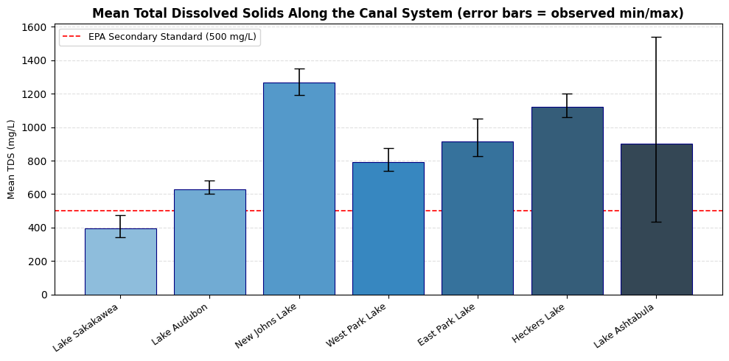
Figure 2 - Bar Chart of TDS Concentrations
There were multiple parameters in the dataset that exceeded EPA secondary standards or showed increases along the canal.
Sulfate showed the largest increase of any parameter. Concentrations rose from a median of 159 mg/L in Lake Sakakawea to over 720 mg/L in New Johns Lake. This increase ends up going above the EPA secondary maximum contaminant level of 250 mg/L and can have aesthetic and infrastructure related concerns.
Total Dissolved Solids (TDS) followed a similar pattern, increasing from 395 mg/L to over 1,260 mg/L and then decreasing towards the end of the canal. Lake Ashtabula levels ended up being lower with a median of 842 mg/L which is still much higher than the EPA secondary standard of 500 mg/L.
Magnesium had levels that doubled from the source to Lake Ashtabula. This directly increases carbonate hardness as well, which is over 400 mg/L at the endpoint of the canal. These parameters and their patterns of concentration along the canal show that water quality starts to deteriorate as water moves down the system.
Between Lake Audubon and New Johns Lake there is a clear change in water chemistry and chemical concentrations. This means that certain factors like local geology and municipal dealings could be contributing to changes in sulfate, magnesium, calcium, and bicarbonate. While these concentrations do start to partially recover, they do not return to levels seen in Lake Sakakawea. This information is displayed in Figure 3 showing the boxplots of parameters at the locations measured in the system.
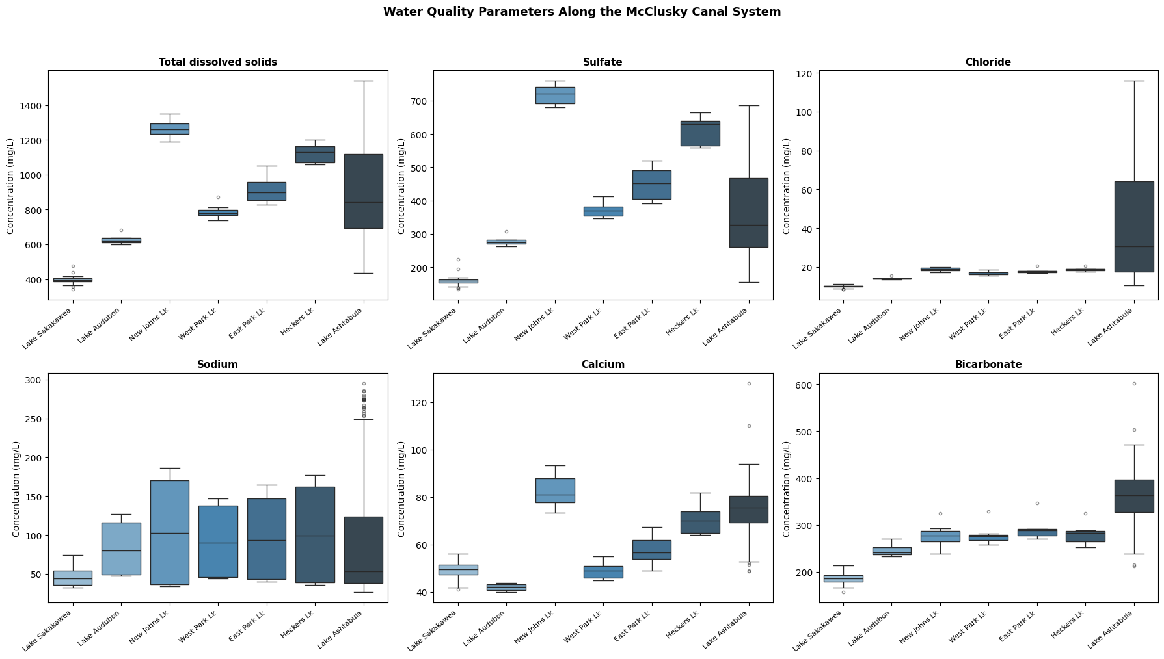
Figure 3 - Boxplots of 6 Parameters Along the Canal
A steady state mass balance equation was used to estimate the final TDS concentration in Lake Ashtabula after mixing Sheyenne River flow with water from the pipeline. This equation is shown in Figure 4.
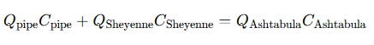
Figure 4 - Mass Balance Equation
The pipeline flow was then estimated using baseline assumptions shown in Table 2. Under these conditions the predicted TDS concentration is 764.6 mg/L. This ends up lower than the Sheyenne River alone which is 809 mg/L meaning that the pipeline influence on TDS is negligible. These numbers can be easily changed in the Python coding document to evaluate different scenarios of TDS mixing.
Table 2 - Mass Balance Python Output Table
Mass Balance – TDS in Lake Ashtabula
Pipeline TDS (median Lake Sakakawea) | 394.5 mg/L
Sheyenne TDS (median Sheyenne River) | 809.0 mg/L
Q_{Pipe} (design) | 6.0 cfs
Q_{Sheyenne} (approximate low flow) | 50/0 cfs
Baseline Mixed TDS (Lake Ashtabula) | 764.6 mg/L
Total Flow into Lake Ashtabula | 56.0 cfs

A temporal trend analysis was also done in Python using statsmodels. This ended up showing increases in TDS and sulfate at Lake Ashtabula and Lake Sakakawea over time. Lake Ashtabula showed the strongest upward trends showing that the end of the system was worsening faster than at the source. All graphs are in Figure 5.
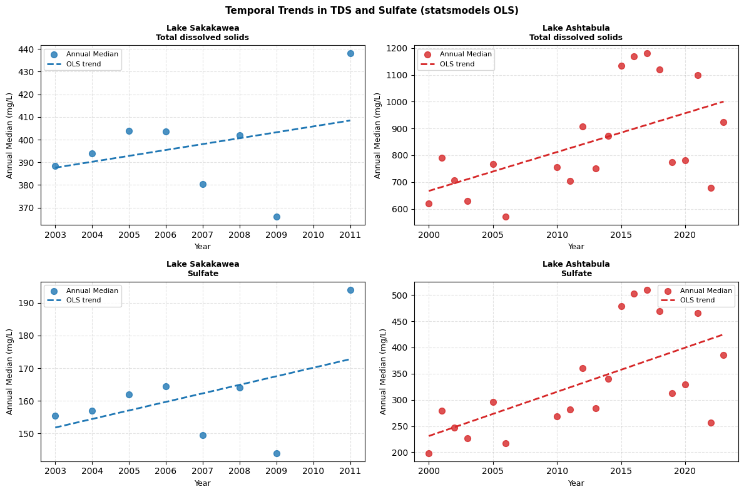
Figure 5 - Temporal Trend Analysis
All analyses done with choices about what to use from a dataset can introduce bias. The purpose of this paragraph is to document choices made over the course of this project so that any bias that may have occurred is documented. The median was used as the measure of the center of parameter data rather than the mean due to typical skews. All NaN values for any parameter were not used and were discarded during the cleaning of the data. The mass balance equation assumes steady state and complete mixing. No outliers were removed from the data, just non-values. Finally, the temporal trend analysis assumes a linear relationship between year and concentration but there were not enough values at some sites to definitively state whether this is true.

References

